**EXPERIMENT 6**

**DML COMMANDS (COLLEGE SCHEMA)**

**Aim:**

* Insert 5 instances into the tables created in experiment 6.
* Display the tables.
* Add attribute course to student table then insert values.
* Use update to set course for students.
* Delete an attribute.

**Components:**

1. DML(Data Manipulation Language):The SQL commands that deals with the manipulation of data present in the database belong to DML or Data Manipulation Language and this includes most of the SQL statements.

Examples of DML:

* + [INSERT](https://www.geeksforgeeks.org/sql-insert-statement/) – is used to insert data into a table.
  + [UPDATE](https://www.geeksforgeeks.org/sql-update-statement/) – is used to update existing data within a table.
  + [DELETE](https://www.geeksforgeeks.org/sql-delete-statement/) – is used to delete records from a database table.

**Code:**

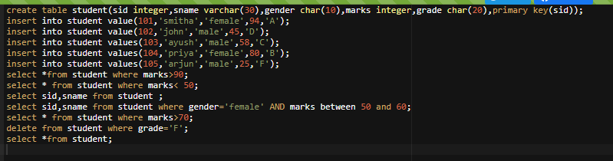

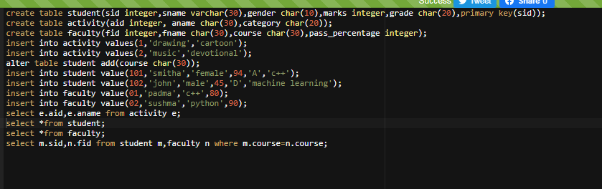

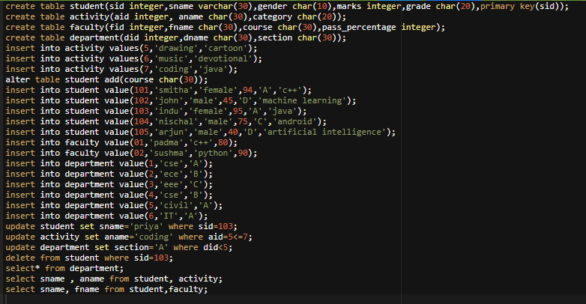

**Output:**

sid sname gender marks grade

101 smitha female 94 A

sid sname gender marks grade

102 john male 45 D

105 arjun male 25 F

sid sname

101 smitha

102 john

103 ayush

104 priya

105 arjun

sid sname gender marks grade

101 smitha female 94 A

104 priya female 80 B

sid sname gender marks grade

101 smitha female 94 A

102 john male 45 D

103 ayush male 58 C

104 priya female 80 B

aid aname

1 drawing

2 music

sid sname gender marks grade course

101 smitha female 94 A c++

102 john male 45 D machine learning

fid fname course pass_percentage

1 padma c++ 80

2 sushma python 90

sid fid

101 1

did dname section

1 cse A

2 ece A

3 eee A

4 cse A

5 civil A

6 IT A

sname aname

smitha coding

smitha coding

smitha coding

john coding

john coding

john coding

nischal coding

nischal coding

nischal coding

arjun coding

arjun coding

arjun coding

sname fname

smitha sushma

smitha padma

john sushma

john padma

nischal sushma

nischal padma

arjun sushma

arjun padma